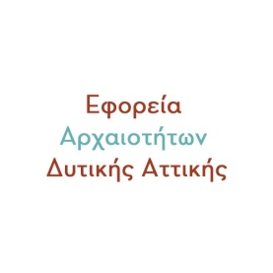
Εφορεία Αρχαιοτήτων Δυτικής Αττικής

Ephorate of Antiquities of West Attica

August 2023 Full Moon Celebration

The Ephorate of Antiquities of Western Attica will celebrate the Full Moon of August 1st this year with the musical event: "A walk on the moon", which will take place in the courtyard of the Archaeological Museum of Megara, in co-organization with the Region of Attica and the Municipality of Megara.

Morpho Tsaireli, an accomplished performer of quality Greek song, will "travel" the audience with music by Hatzidakis, Theodorakis, Xarhakos, Loizos, Moutsis, Spanos and other great composers who set the poetry of Nikos Gatsos, Odysseus Elytis, George Seferis to music. , of Pythagoras, Eftychia Papagiannopoulou and others. The performer will be accompanied by guitarist Spyros Papanikolas.

The event will run from 21:00 to approximately 23:00.

Free entry for the public.

